**Green Society Public School**

**D- 04**

**Ratnanagar-7, Sauraha, Chitwan**

**Second Terminal Examination-2082**

**Class: Four Time:2 hrs. F.M.:50**

**Sub:** Mathematics

1. **Construct an angle of 500 with help of Protractor.**
2. Name the angle formed. [1]
3. 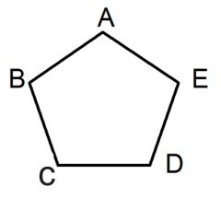Name the vertex of the angle formed. [1]
4. Name the arms of angle. [2]
5. **A plane figure is given.**
6. Name the given plane figure. [1]
7. Name the sides of the given figure. [2]
8. How many corners are there in the figure? [1]
9. **Ghanshyam wants to buy motorbike. If the cost of a motorbike is Rs. 4,79,308. Then,**
10. Write the place and place value of 7. [2]
11. Write the price of bike in numeral according to national number system. [2]
12. **Answer the following questions.**
13. How many vertices are there in a cone. [1]
14. Write the five greatest number. [1]
15. Compare using >, < or = [2]
16. 87345 ________78,435
17. 5000__________5100
18. **In the box with appropriate word, number or symbol.**
19. 6 x 2 x 6 [1]
20. +10 = 20 [1]
21. 30 - = 25 [1]
22. 25 x 5 = x 25 [1]
23. 35 = +5 [1]
24. **The details of income and expenditure of Ram’s family are given in the table below.**

|  |  |  |  |  |  |
| --- | --- | --- | --- | --- | --- |
| ***Income*** | | | ***Expenditure*** | | |
| **Sources** | | **Amount (Rs)** | **Topics** | | **Amount (Rs)** |
|  | Salary | Rs. 50,000 |  | Food | Rs. 10,000 |
|  | Rent | Rs. 20,000 |  | Internet | Rs. 3,000 |
|  |  |  |  | Health | Rs. 12,000 |
|  |  |  |  | Education | Rs. 25,000 |
|  |  |  |  | Loan | Rs.10,000 |
| Total | | Rs.70,000 | Total | | Rs. 60,000 |

1. What is the total income of household? [1]
2. How much is the expenditure on food? [1]
3. What are the sources of income of the household? [1]
4. What is the salary of the household? [1]
5. How much money does Ram’s family spend on education and internet combined? [2]
6. **Solve the following.**
7. There are 11 players in football team. Find the numbers of players in 15 teams. [2]
8. Find the product of 25 x 30 ? [2]
9. 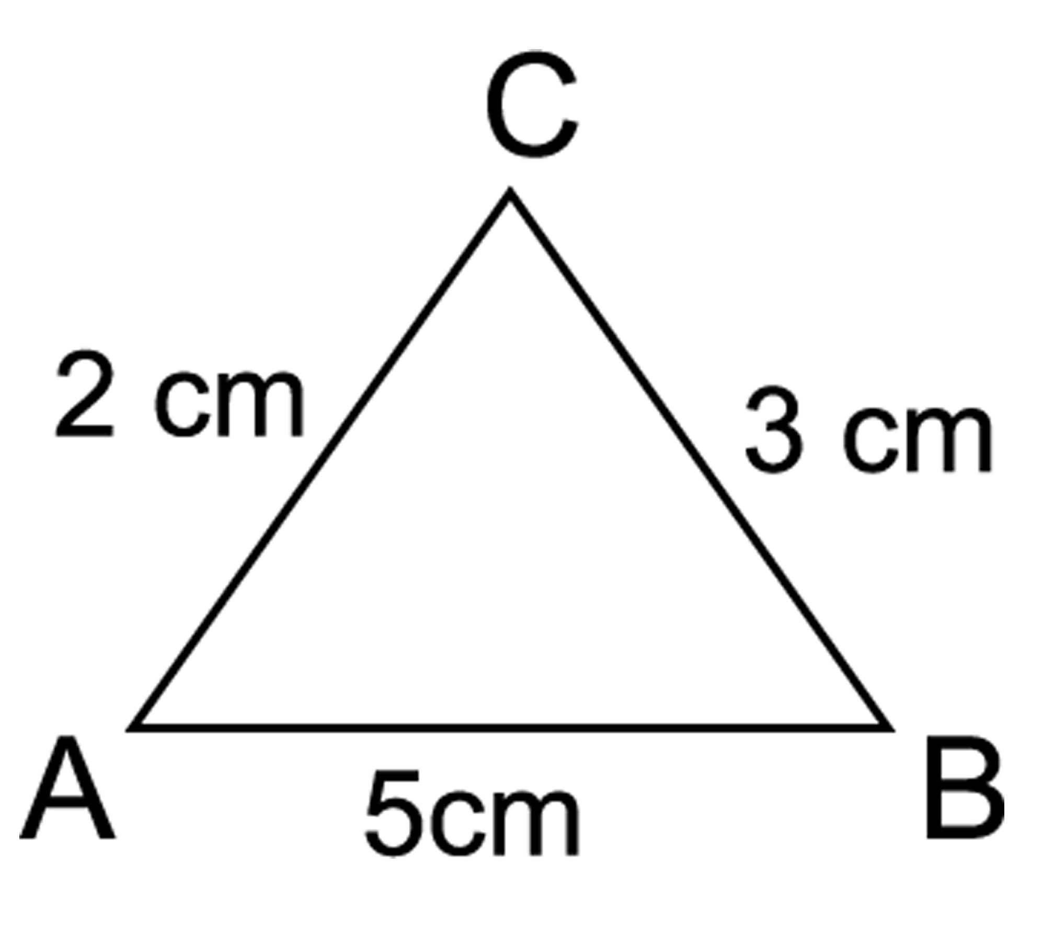Construct a line segment of 5cm with the help of ruler. [1]
10. **Answer the following questions.**
11. Find the perimeter of given triangle. [2]
12. Classify the following angles. [Acute Angle, Right Angle, Obtuse Angle, Straight Angle]

900, 250, 1500, 1800 [2]

1. **Write the answers of the following questions.**
2. A library had 52,000 books, if it bought 15000 new books. How many books are there in total now ? [2]
3. Subtract: 4 5 9 3 2 [1]

* 1 2 5 4 3

1. **Complete the following [4]**
2. 2 4 6

+ ....................... + .......................

1. 12 10 8

– ................... – ....................

**11. Complete the following patterns.**

1. 110, __________, 130, __________, 150 [1]
2. 3, 6, 9, __________, ___________ [1]
3. __________, 700, __________, 900, 1000 [1]

**12. Population of Chitwan district is 579,984.**

1. Write the population of Chitwan in Devanagari numeral. [1]
2. Represent the population in a place value chart. [2]
3. Expand the population of Chitwan. [1]

**The End**